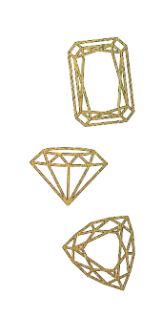

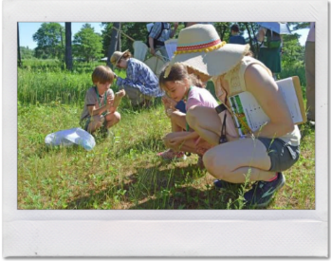
Dear Supporter,
For the health and well-being of our community, we have decided to forego an in-person event in 2021 and hold our event virtually once again. Now more than ever, your Community Foundation needs your support. We hope you will consider sponsoring or donating to our Jeans & Jewels Charity Gala, benefitting the Community Foundation of Dunn County. May we count on your support?
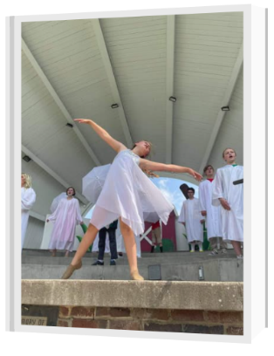
Jeans and Jewels is a special annual event that raises money for our ongoing work in philanthropy, collaboration, and leadership. It will be held virtually the evening of Saturday, November 6, 2021. Our annual gala is our only fundraiser to support our mission-based operations.
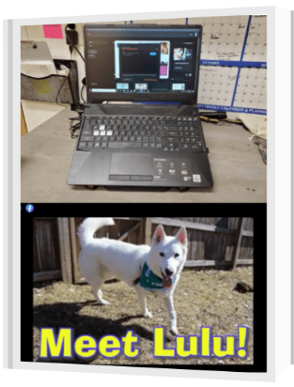
Whether it's midnight on a Friday or 9 AM on a Monday, one of our funds is having an impact somewhere in Dunn County. In the last 12 months, we have supported several community organizations through our competitive grant cycle. We helped the Dunn County Humane Society purchase new technology for their social media specialist, as well as supported their Safe Harbor Program, which provides free veterinary services for pet owners living at Bridge to Hope Facilities. We helped the Menomonie Theater Guild with their Children's Summer Program. We helped the Dunn County Historical Society initiate Finders BioBlitz, an event which brings community members and environmental professionals together to explore nature and observe plants and animals living in Dunn County. We also helped fund educational initiatives such as mental health video programming at Boyceville School District, scholarship assistance for the Chippewa Valley Boy Scouts, and the Reach out and Read Pediatric Literacy Program at Mayo Clinic-Red Cedar.
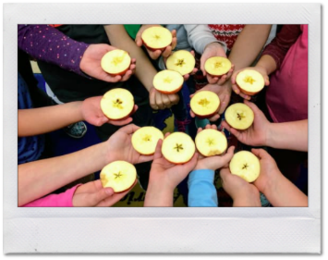
Our event sponsorship and donation opportunities are included. Several levels of sponsorship, including three EXCLUSIVE options, give you the opportunity to be featured in our pre, during and post-event promotion that reaches thousands of people across the area. But we must hear back from you by September 20th to offer you the full benefits. Thank you very much for your consideration.
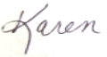
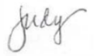
Sincerely,

Celene Frey Judy Foust Karen Styer
On behalf of the Board of Directors of the Community Foundation of Dunn County
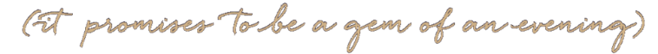

800 Wilson Ave, Suite 235 Menomonie, WI 54751 cfdunncounty.org 715-232-8019

