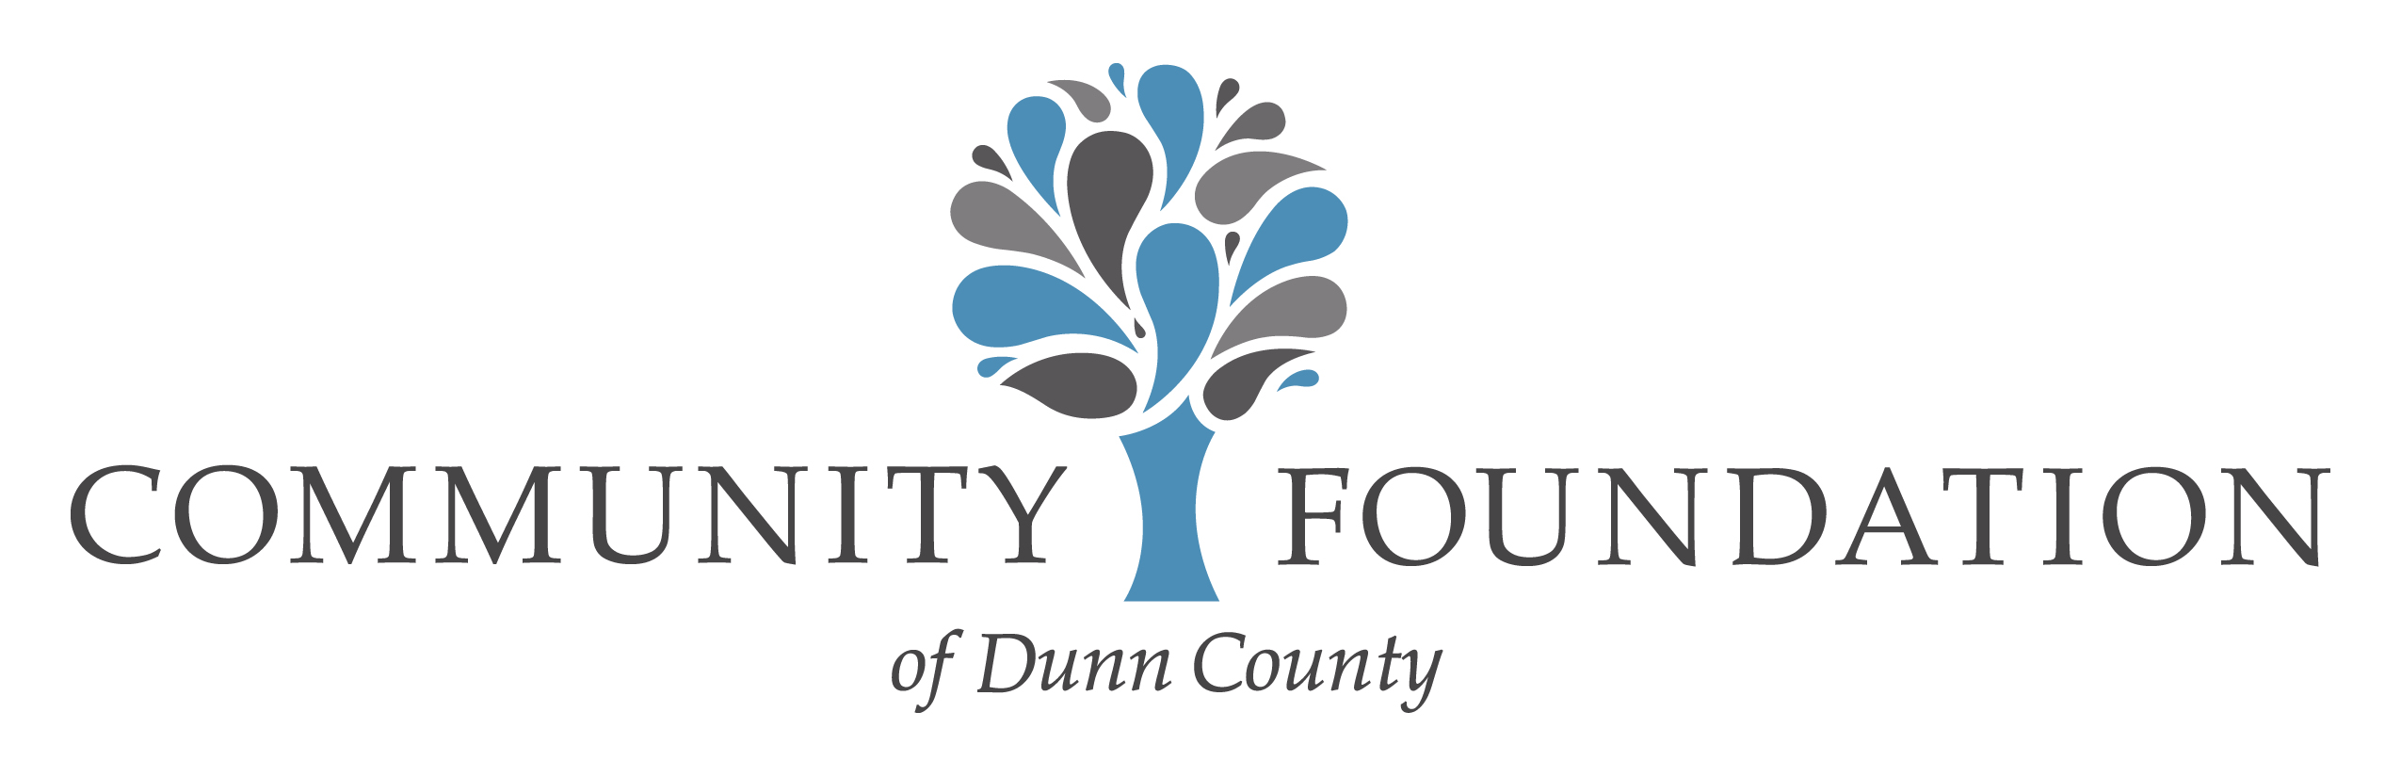
Legacy Society – Notice of Intent

The Community Foundation of Dunn County Legacy Society seeks to recognize all those who have included the Community Foundation in their will or other deferred giving plan.

To serve as notice and advice to my estate planning advisor and the executor of my estate, this non-binding Letter of Intent represents my/our preference that the gift described below will be made to the Community Foundation of Dunn County on my/our behalf.

It is my/our intention to update our estate plan at the next available opportunity, with the following provisions:

Provide a gift:
□ ____ per cent of the estate.
□ a specific dollar amount to be specified in the estate plan.
□ an amount to be specified by my heirs
□ from a life insurance policy
□ from a retirement account.
□ of real estate
□ other

Note: We encourage you to discuss these options with your family and with your attorney, accountant, insurance agent or financial planner as may be appropriate. You may also contact the Foundation office to discuss the various ways to leave your legacy through the Community Foundation.

I/We hereby state the intent to make a gift to the Community Foundation of Dunn County (CFDC) from my/our estate in accordance with the provisions stated above. In addition to those provisions, I/we wish to be included in the Legacy Society and agree to be included in published listings of the Society’s members.

Dated this day of , 20 .

Please print name(s) as you wish to be listed.

Signature(s)

Community Foundation of Dunn County
PO Box 498 500 Main St. #322
Menomonie, WI 54751
715.232.8109 info@cfdunncounty.org
People Who Care…Causes That Matter.

P:\CFDC\Legacy Society\Letter of Intent.docx

