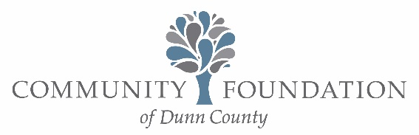

Board of Directors Meeting May 22, 2025
City Hall Chambers
Meeting Minutes

Present: Bill Butsic, Karen Styer, Jenn Tack, Brad Waznik, Jeana Larson, Sandi Scott via Zoom, Mike Fekete, Paul Horvath-via Zoom, Dianna Fiergola, Kevin Nolan, Amy Hellman via Zoom, Stacy Medin, Georgina Tegart, and Liz Forster.

Absent: Elizabeth Serratore

Call to Order 7:34

Welcomed Stacy Medin as newest board member.

Consent Agenda – Motion to approve consent agenda by Fiergola; second by Styer. Carries.

Downtown Menomonie Fire – Discussion regarding the fire consuming a building in downtown Menomonie this week leaving the loss of one business and nine residences and the additional damage and loss of contents to another business. Motion to approve $1,000 grant from the Common Good Fund to the Red Cross by Waznik; second by Tack; carries.

Executive Director Update
Annual Luncheon was well-received as 26 grants were awarded.
Scholarships-All awards ceremonies are complete, and 2025 scholarships have now moved into the acceptance process.
Flag Day is the next Foundation event. It is held on June 14th.
Legacy Picnic is on schedule, except a replacement speaker is needed.
Jeans and Jewels planning has started.
Metrics highlight new funds being started and donations received already this year.

Investment Committee
Waznik reported that rebalances were made after the quarter.

Finance Committee
Fekete reported the 990 has just been completed. The board will vote on it in June to allow time for review.

Grants Committee
Horvath reported the committee will meet on June 2 to address Strategic Planning.

Fundraising, Communications and Marketing Committee
Styer reported on the success of the Annual Luncheon, and that the committee has moved into Jeans and Jewels planning on top of final preparations for the Legacy Picnic. Butsic noted the name of the committee will now be Events and Marketing to better reflect the committee’s scope.

Board Business

Motion to approve changes to signatories on checks to include Butsic, Nolan, Fekete and Tegart with limits on Tegart of $2,500 maximum, must have prior authorization in writing from Fekete, Nolan or Butsic to pay the credit card billing, and may not sign any checks payable to herself by Waznik; second by Medin; carries.

Motion to approve a nonendowed DAF fund named “the one small step fund” to be started by a group of friends (Howe, Szymanski, Forster, Jeatran, and Wood) by Fiergola; second by Nolan; carries.

Motion to review the fees on the Ron and Joan Sandfort Designated Endowed Fund by Fekete; second by Fiergola; carries.

Motion to approve the grants from the Bruce and Katherine Rhoades Fund to Dunn County Human Services by Fiergola; second by Larson; carries

Fund Asset Development
Fekete reported they met with three committee members and reviewed metrics, but without enough members attending to take any actions.

Executive Committee
Butsic focused on this year’s review and updates to the Strategic Plan. The Executive Committee has completed their area review and their results and changes may be used as the example to the other committees. It identifies the basic ongoing priorities and can be adjusted. The committee changes are expected by August and should identify roughly 5 workable objectives and the plan to achieve measurable results.

General community discussion followed as time allowed. The June 26th Board meeting was noted and that July would not have a Board meeting.

Motion to adjourn at 8:42 by Tack; second by Dianna; carries.

