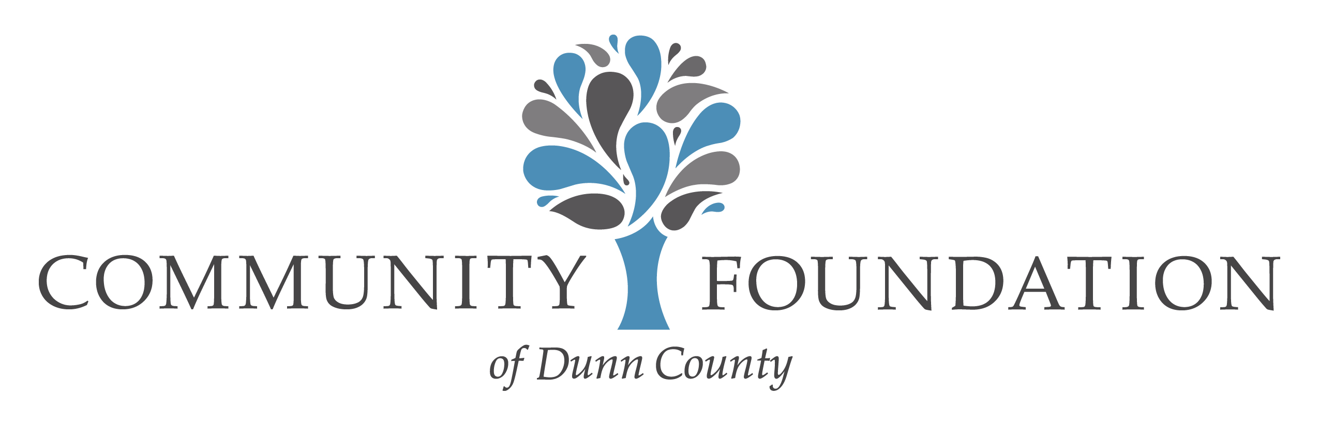

CBJ Kids to Camp Scholarship Application
The CBJ Kids to Camp Scholarship Fund was established by the family of Cammie B. Johnson, a young woman who passed away just before her 21st birthday from complications of diabetes. Cammie spent many summers at Camp Sioux and Camp Needlepoint, also serving as a camp counselor and mentor for younger children experiencing the difficulties of living with diabetes.

This scholarship allows applicants to attend summer camps specifically designed for children with diabetes. The camp must be a qualified 501(c)(3) non-profit organization. This application and a list of qualifying camps is available on our website at www.cfdunncounty.org. Scholarships are awarded in accordance with the policies and procedures of the Community Foundation of Dunn County.

Scholarship amounts range from $300 up to $850 and are paid directly to the camp unless otherwise approved by the Community Foundation of Dunn County, Inc. Any income tax liability that could result as the result of a direct tuition reimbursement is the responsibility of the applicant or parents as may be applicable.
Scholarship Requirements:
- The chosen camp must be certified by the American Diabetes Association
- Submit a completed Application Form (attached)
- Include brochures or other official information describing the camp program
- Provide a copy of the completed camp registration form
- Provide a copy of the camp’s acceptance notification
- Essay (typed, 250 – 500 words) describing how being able to attend camp will (1) make a difference in your life and (2) how you can use the camp experience to help other young people facing the challenges of living with diabetes.
Submit completed applications and related materials at least (8) weeks prior to the scheduled camp to:
Community Foundation of Dunn County
PO Box 498
500 Main Street #322
Menomonie, WI 54751

For questions or more information call 715.232.8019
or e-mail grants@cfdunncounty.org

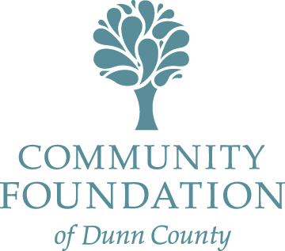
CBJ Kids to Camp
Scholarship Application Form

Applicant Information
Name ___________________
Last First Middle Initial
Mailing Address

County of Residence School Name

E-mail Home Telephone

Gender Date of Birth

How did you hear about this opportunity? _______________________________________________________

Camp Information
Camp that you plan to attend:
Camp Mailing Address:__________________________________________________________________
Camp Date(s):_________________________________ Total Cost of Camp:_______________________

Amount Paid To Date:______________ Scholarship Amount Requested (not to exceed $850): $________
(Please attach information about the camp – brochure and/or other information that provides details about the type of programs offered, costs, dates, etc. You may include printed information from the Camp’s website.)

I certify that the information provided in this application is complete and accurate to the best of my knowledge. I understand that falsification of information will result in termination of any scholarship granted. I understand that incomplete applications may not be considered. I certify that I have read the instructions and will comply with all requests for documentation. Should I receive a scholarship, I will notify the Community Foundation of Dunn County (CFDC) of any change of plans. The CFDC may use my name and likeness in publicity materials relating to the Foundation.

I understand the CFDC scholarships may only be used toward the published cost of attendance at qualified camps. (Qualified camps are those that are specifically designed for youth and young adults that have Type I Diabetes. Camps may be for educational, athletic, or other types of personal development.)

Applicant Signature Date

Signature of Parent or Guardian (if applicant is under 18) Date

